THE HONG KONG UNIVERSITY OF SCIENCE AND TECHNOLOGY
DEPARTMENT OF CIVIL AND ENVIRONMENTAL ENGINEERING

CIVL 1100 Discovering Civil and Environmental Engineering



Report on Geotechnical Engineering Experiment
Spring 2024

Name of student : Hau Ka Yi
Suo Xun Xin
Siu Hok Vaness
Tai Danielle Ho
Student ID number : 29583380
20703125
20794196
21352871
Date of experiment : 2024-04-30
Group number : A10
Date of submission : 2024-05-07
Total marks : /50

Submit your lab report electronically to CANVAS by 11:59pm on May 7 – For sessions on April 30; or 11:59pm on May 14 for sessions on May 7.

OBJECTIVES AND TEST PROCEDURES

  - Introduce the objectives of the laboratory soil liquefaction test. (2 marks)

- To gain insight into soil liquefaction
- To identify key factors that influence soil liquefaction

  - Summarize the procedures of sample preparation and the earthquake-shaking experiment.
(Please use your own words!) (4 marks)

Procedure of sample preparation:
- Prepare 10kg of Toyoura Sand.
- Use a measuring cylinder to measure 2400 mL or 2600 mL (depending on different groups) of water in test 1, 2, 3, 4.
- Prepare a Perspex soil container, pour 8 to 10 scoops of Toyoura sand into the container while adding around 500 mL into the container
- Mix sand and water uniformly to ensure that the sample is at a loose state
- Repeat the above procedures until water is all used and all sand are mixed uniformly and loosely in the container and ensure that we do not compact the sand bed during this process
- Use the sand to make a flat land for test 1 and 2, or make a 20 degree slope for test 3 and 4, but do not compact the sand
- Measure the height of the soil in right end, middle, and left end of the width of the soil sample with a rule to compute the average height of the soil sample
- Measure the other dimensions (length and width) of the soil sample to compute the volume of the soil sample
- Insert the pile foundation model into the sand bed.

Earthquake-shaking experiment:
We will use NAWS-Z30 earthquake shaking table to simulate earthquake loading.
- Fix the Perspex soil container on the shaking table
- Use control program from NAWS-Z30 earthquake shaking table to adjust the shaking amplitude and frequency
- Observe and record soil and structure behaviours during the simulation
- Loosen the Perspex soil container and clean it after the shaking test

  - During the laboratory test, a few factors influencing the soil liquefaction potential were studied. Please fill in the table with relevant factors and their SI units. (5 marks)
Hints:
1. You may find the answers from the PPT presented and your own observations during the lab session
2. The slope is NOT a factor that will influence the potential of liquefaction

Factor | Unit [ ]
Shaking intensity (Amplitude) | m/s²
Duration of shaking | s
Frequency | Hz
Volumetric water content | mL
Soil density | kg/m³

CALCULATION AND OBSERVATIONS

- Calculate the gravimetric water content (w) and volumetric water content (θ) of the soil sample in your group. (6 marks)
(Apply the described assumption and use the following equations. Please also indicate your group number.)
Assumption: Mass of water: 1 kg/litre
Group number:
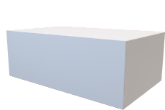
H mm
H mm

W mm
L mm
W mm
L mm

$$W=\frac{mass of water}{mass of soil},θ=\frac{volume of water}{volume of the sandbed}$$

Group number: A04

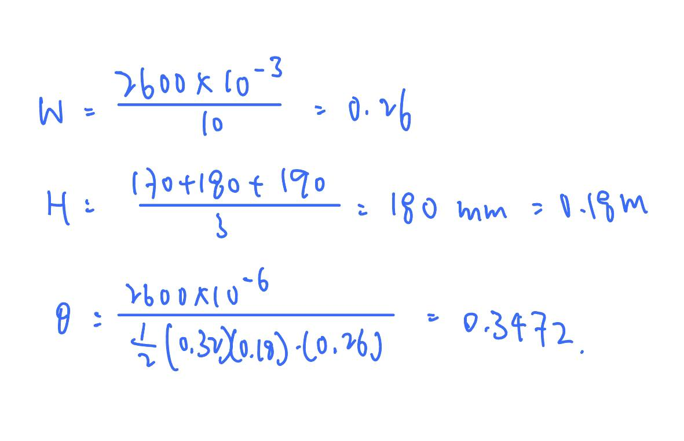

- Please describe your observation during the lab session BRIEFLY.
(e.g.: What happened to the sample, water, and the pile foundation?) (12 marks)

Test 1 (Water = 2400 mL; Intensity = 9 m/s²; Without slope)

There are no observable changes. The pile foundation did not deform and tilted. Soil liquefaction did not occur.

Test 2 (Water = 2600 mL; Intensity = 9 m/s²; Without slope)

Soil liquefaction has occurred during shaking as water starts leaking out on the surface of the soil. Large amount of gas bubbles can be observed, indicating the occurrence of sand boiling. The pile foundation sinks at a rapid rate just after the occurrence of liquefaction.

Test 3 (Water = 2600 mL; Intensity = 9 m/s²; With slope)

A low level of sand water at the bottom of the slope can be observed and this might indicate the occurrence of soil liquefaction during shaking. The slope seemed to progressively fail. But the deformation was so subtle that it is hard to observe. Also, there were few water bubbles can be seen. Moreover, the pile foundation did not seem to tilt and fail. To conclude, it was difficult to determine whether the slope has undergone sand boiling.

Test 4 (Water = 2600 mL; Intensity = 12 m/s²; With slope)

Like the result in Test 3, there was a low level of sand water at the bottom of the slope. However, there was a comparatively deeper water level in the bottom of slope. Also, the slope fell at a faster rate than the sample in Test 3. The pile foundation did not seem to tilt and fail as Test 3 did. There were also some water bubbles can be observed, that might also indicate the occurrence of sand boiling as Test 3 did.

DISCUSSION
- Compare results of the experiment of your group with those of others. Discuss the differences in properties of soil samples and results observed during the earthquake shaking. (9 marks)
Hint: If the relation between the parameters and the liquefaction potential of 2 tests is not clear, just write down “NOT CLEAR” in the “Potential” box.

Comparison between | Differences in parameters, effects on liquefaction potential |  | Discussion  (Difference in results and possible reasons)
 | Parameters | Potential | ------
Example:  Test X, Test Y | w | Test X >Test Y | …… (Your own discussion)
 | Intensity | Same
 | Slope | NOT CLEAR
Test 1, 2 | w | Test 2 > Test 1 | Result in Test 1 did not show the occurrence of soil liquefaction, but Test 2 did.  The water content in soil sample 2 is higher than soil sample 1 as more water are added to the sample. Therefore, soil sample 2 is more saturated. The cohesion of sand in soil sample 1 is higher than soil sample 2. As a result, the shear strength of soil sample 1 is stronger than soil sample 2. So, sand in test 2 lost its shear strength quickly and liquified. To conclude, the water content, more likely to occur soil liquefaction under same volume of sand bed.
 | Intensity | Same
 | Slope | Same
Test 2, 3 | w | Same | The main difference between Test 2 and Test 3 is the degree of slope. The result of Test 3 is that the slope deformed progressively from the bottom to the top unlike the Test 1 and 2 that soil liquified and pile foundation fell on the ground. Test 3 with the same water content but different degree of slope occurs lateral displacement of soil on the slope. Upper layer of soil is sliding on the liquified layer so this may cause pile foundation failed and tilted.
 | Intensity | Same
 | Slope | Test 3 > Test 2
Test 3,4 | w | Same | The salient difference is the shaking intensity. Both Test 3 and Test 4 have resulted in a low of soil water at the bottom. But Test 4 has a deeper level of soil water and perhaps more bubbles at the surface of soil water. The intensity of Test 3 is 9 m/s² and Test 4 is 12 m/s². Other variables (volume, water content and amount of sand) are conserved. This means the shaking force in Test 4 is higher than in Test 3. Although soil liquefaction is not obvious in both Test 3 and Test 4, we still see that the degree as well as the rate in Test 4 is higher than in Test 3.
 | Intensity | Test 4 > Test 3
 | Slope | Same

- Please carry out small research on slope reinforcement methods. Provide at least 2 solutions for slope reinforcement and describe how they work BRIEFLY. (Use ~150 words) (12 marks)

The first solution is by building retaining walls. These walls can be located at the river edge where they can be an extension of a wall or can be placed bac from the river edge to allow for a trail or other uses between the edge and the back slope. Also, bricks, concrete or stone made walls can allow the soil to keep a smaller slope angle. Drainage systems are sometimes added to the walls which are also capable of withstanding hydrostatic pressure. Therefore, they are used to reinforce slopes.

The second solution is to cover slopes with mesh. The mesh is draped across the slope in a manner to ensure optimal coverage and contact with the surface. When erosion occurs behind the mesh layer, it can effectively act as a barrier, controlling the movement of the debris as it descends the slope.

The third solution would be planting trees on the slope. As the trees grow, the roots will develop and extend both deep into the soil and onto the surface of the soil to strengthen the surface strength, as well as the strengthening effect on the soil slope. The friction among the soil will increase, also increasing soil stability.

